- Go to the following link (and sign in with CU Anschutz credentials): https://share.percipio.com/cd/yRUzmIVfJ

- Select “Launch”:
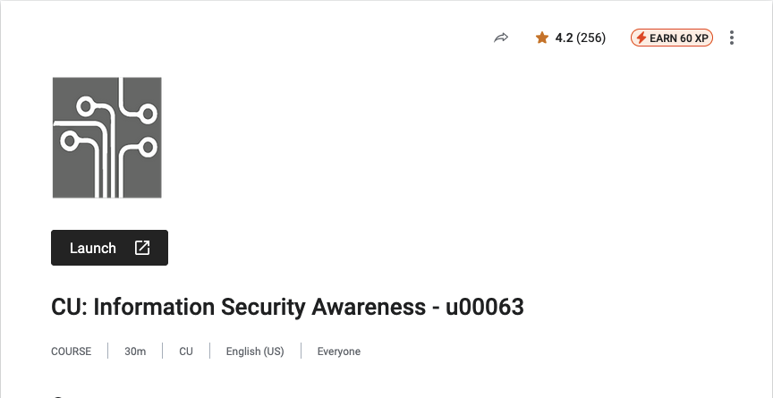
- The Course should Launch in a separate window. You may need to allow the popup first, depending on your browser
- Once you have gone through the course and accepted the acknowledgement, you will be required to take a quiz and score a 70% or higher:
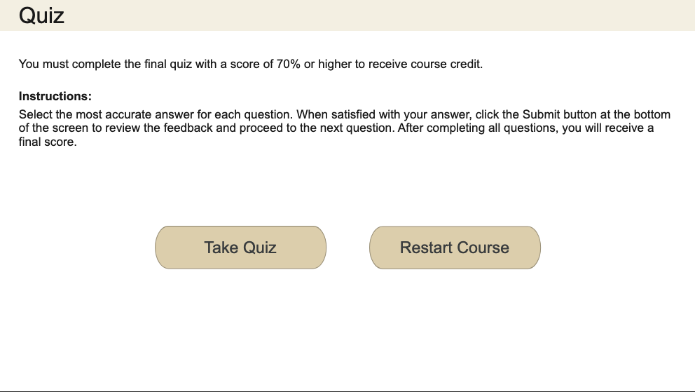
- Once you have finished the quiz, you should click “Continue”:
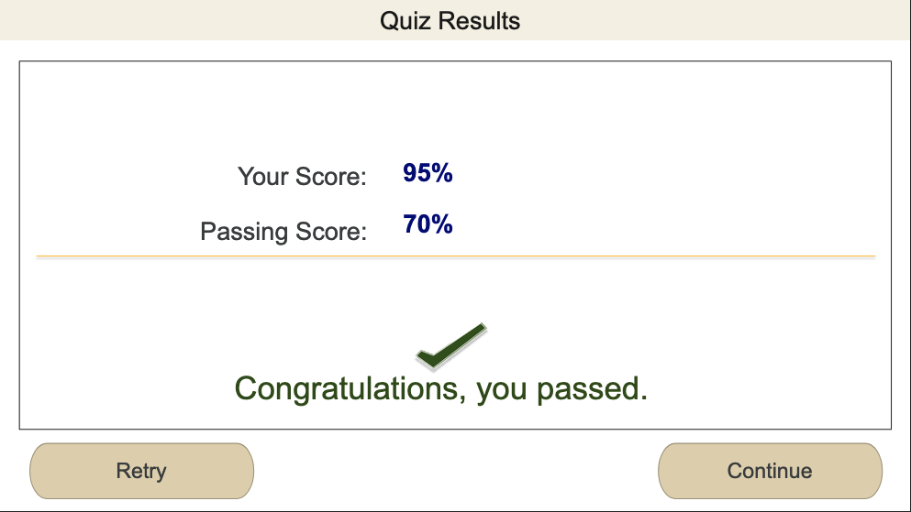

- Once you have competed the course and closed the window, you must find and upload the dated certificate of completion. From the Percipio window you opened in step 1, navigate to the 3 lines on the left and select “My learning”:
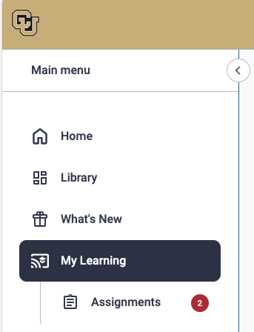
- In the middle of the page, you should see a section with the header “Your Recent Activity”, with “CU: Information Security Awareness - u00063” recently completed. Select the 3 dots to the right and click “Download Certificate”:
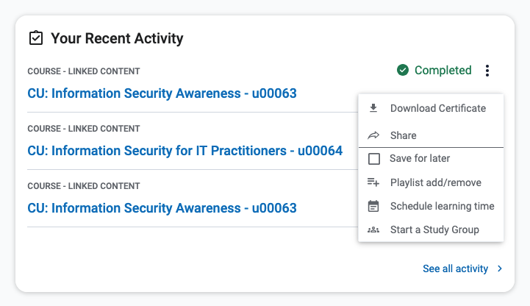
- From there, upload the Certificate to the new EUA: